Migration Trends in and out of Kyrgyzstan: Data Analysis and Visualization



Course: Data Analysis and Visualization

Author: Sadiev Aiman, Almazbekov Eldiiar

Professor: PhD Remudin Mekuria

# Table of Contents

# 1.Introduction

## 1.1Why we chose this data?

## 1.2 Methodology

## 1.3 Project Workflow

# 2.Data Description

## 2.1 Data Collecting

## 2.2 External Migration

## 2.3 Important General Details on DataSets

# Data Analysis

## 3.1 Data Preprocessing

## 3.2 EDA

## 3.3 Key Takeaways

## 3.4 Why these charts?

# 4. Visualizations

# 5. Conclusion

## 5.1 What have we done so far?

# 6. References

# 1. Introduction

The report will try to show **migration dynamics** in Kyrgyzstan, based on data from **2011 - 2025** from **national** and **international**databases on migratory flows. It **discusses**recent major global and regional **trends**which will continue to shape **internal and international migration** in the country and where there are **gaps**. It examines data from **government reports**, **international organizations,** and **development agencies** on topics including immigration, emigration, return migration, refugees, irregular migration, internal migration, and remittances.  
There is data on the number of people **immigrating**to the **country**every year but **not finer** points like age, gender, or educational level. The **emigration** data isn't as good — it includes age, gender, place of origin, and destination but does not say anything about work or education.  
Return migration is underreported. There is **no database** to count returnees, and most information is **based on surveys**. Information is mostly available for recent periods. Internal migration and displacement information **does exist**, however much does not include such critical information as education, employment, and gender.  
Higher-level, consistent, and publicly **accessible**data on migration are **needed**overall — particularly in relation to individuals' background, purpose of migration, and long-term migration flows.

1.1 Why we have chosen this data?  
  
Migration data was chosen for this project due to its utmost social, economic, and policy significance for Kyrgyzstan. As one of Central Asia's most migration-poor countries, Kyrgyzstan experiences enormous labor migration, primarily to neighboring countries such as Russia and Kazakhstan. The phenomenon has a remarkable impact on the national economy, family life, and regional development. Migration statistics are highly versatile and multidimensional, allowing for analysis over a variety of variables such as time, space, destination country, age, sex, and ethnicity. This renders it highly appropriate to analyze a wide range of patterns and trends. Moreover, migration statistics correspond with other significant indicators like the levels of unemployment, economic performance, remittances, and urbanization, permitting more extensive analysis and interpretation. The availability of such data from reliable sources, including the National Statistical Committee of Kyrgyzstan, the International Organization for Migration (IOM), UN DESA, and the World Bank, ensures it is reliable and comparable in the long term. Ultimately, migration research supports evidence-based policymaking, helps to recognize vulnerable populations, and informs initiatives to improve migrants' and their families' welfare. These factors make migration statistics a great choice for analysis- and visualization-based research.

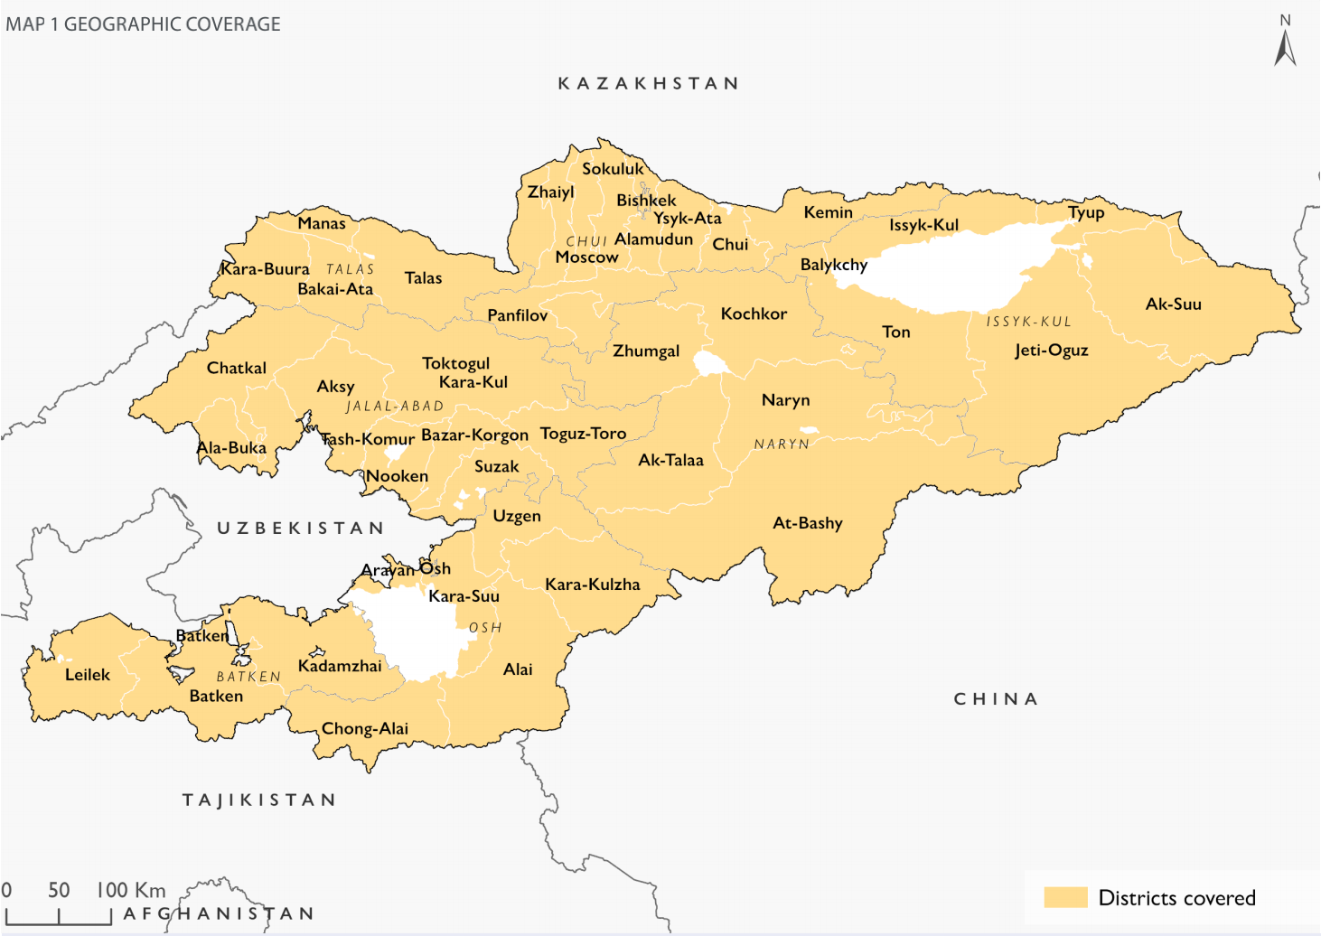

# 1.2 Methodology

The report was prepared based on desk research, literature review, and statistical examination of relevant primary and secondary data. Our analysts pulled and evaluated statistical data, including all the ones that are relevant to examining mobility outflows and inflows into the nation over the last fourteen years.  
The primary aim of this report is to discover data gaps pertaining to various forms of migration in Kyrgyzstan, consolidate available information from various sources, clean and process the data, analyze potential correlations, and ultimately make the data more convenient and useful for further research and policy-making.

# 1.3 Project Workflow:

## Data Collection

Gather pertinent data from multiple trustworthy sources, such as government, international agencies, and open data websites.

## Data Analysis

Analyze collected data to have a sense of its intent and identify which particular statistics are needed to respond to major research questions.

## Data Visualization

Create concise and informative visualization that indicates how data can be interpreted and utilized for practical insights.

## Conclusions and Applications

Conclude the report with detailed recommendations based on the analysis. Select real-world subjects or issues that necessitate statistical information for effective decision-making.

# Data Description

Migration by ethnicity dataset description:

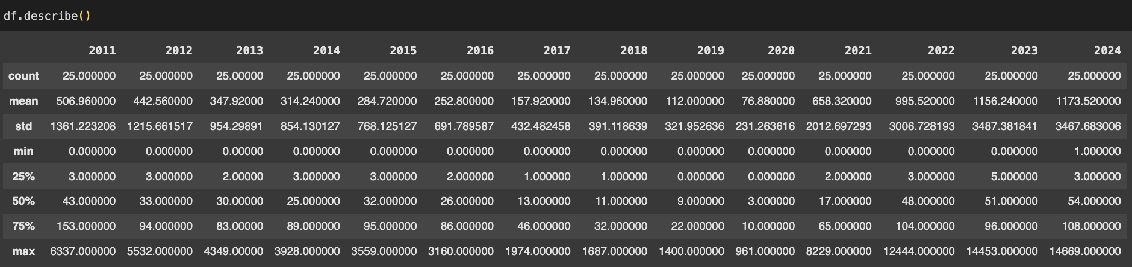

# 2.1 Data Collecting

The data used in this report were collected from some reliable sources, such as national statistical offices, international organizations, and open data sources. Specifically, sources like:

---------------------------------------------------------------------------

MIGRATION SITUATION IN KYRGYZSTAN Compilation report (December 2023)///International Organization for Migration (IOM) Global Data Institute (GDI)

---------------------------------------------------------------------------

MIGRATION DATA GAP ANALYSIS JANUARY 2024/// International Organization for Migration (IOM) Global Data Institute (GDI)

---------------------------------------------------------------------------

National Statistical Committee of the Kyrgyz Republic

---------------------------------------------------------------------------

<https://kyrgyzstan.iom.int/sites/g/files/tmzbdl1321/files/documents/2024-04/compilation_report_dec_2023.pdf>

<https://kyrgyzstan.iom.int/sites/g/files/tmzbdl1321/files/documents/2024-07/mtm-data-mapping_eng_final_0.pdf>

<https://stat.gov.kg/ru/opendata/category/323/>

[https://stat.gov.kg/ru/opendata/category/324/](https://stat.gov.kg/ru/opendata/category/323/)

Each of the data sets tells us that migration in Kyrgyzstan has had waves of rise and fall over the past 15 years. The information is shown by destination nations, ethnic groups, and different regions within the country. These fluctuations enable us to observe in what ways and where people are migrating, and what may be fueling those changes—e.g., economic conditions, political regimes, or individual desires. Looking at this information by region and group also helps identify patterns and areas that might need additional attention or support.

2.2 External migration

As we examined general statistics regarding country and ethnicity of entry and exit, we saw that in some sections, there are missing or incomplete sectors in the datasets. These are harder to complete so that migration trends can be fully grasped and accurately compared between groups. As we point out in the ensuing sections, we mark specifically where data are lacking and propose how more standardized reporting would be beneficial to analysis and decision-making:

---------------------------------------------------------------------------

Here you can see **arrivals**/**departures** by ethnicity that are **short** in data(Estonians/Belorussians/Lithuanians/etc.)

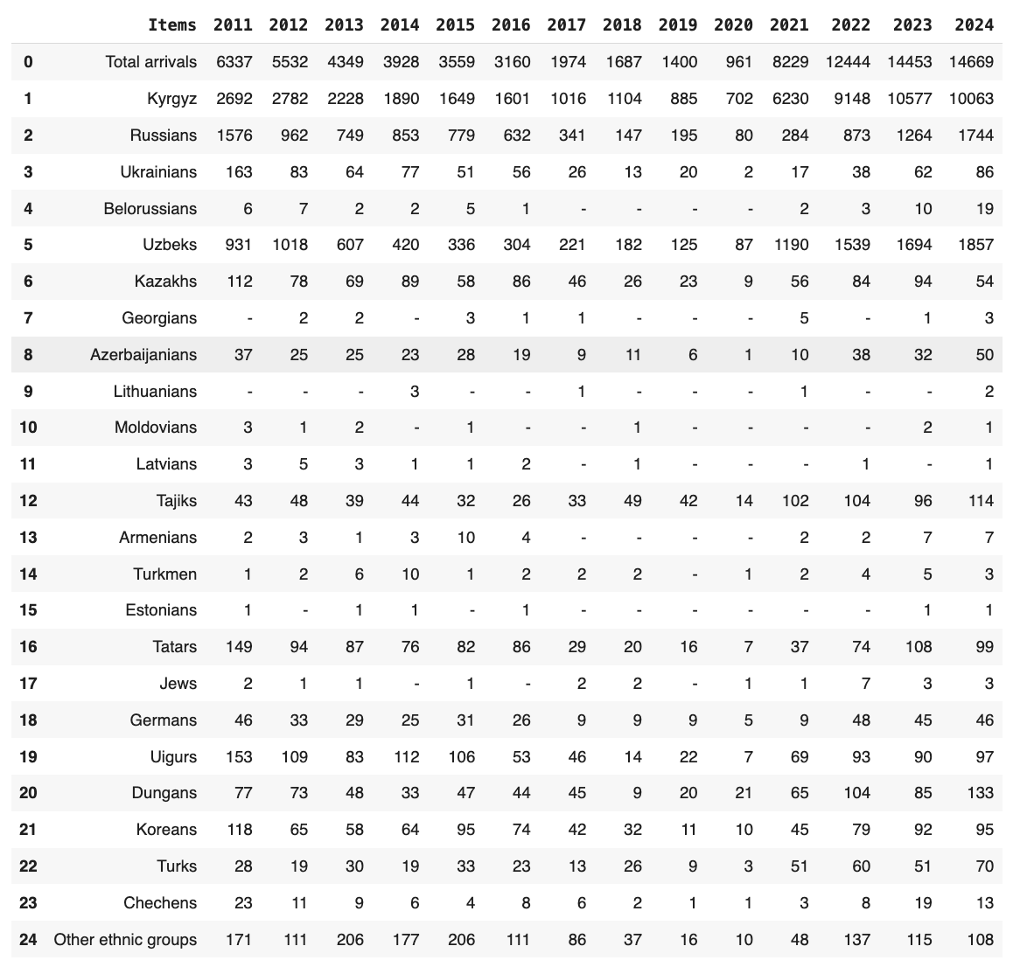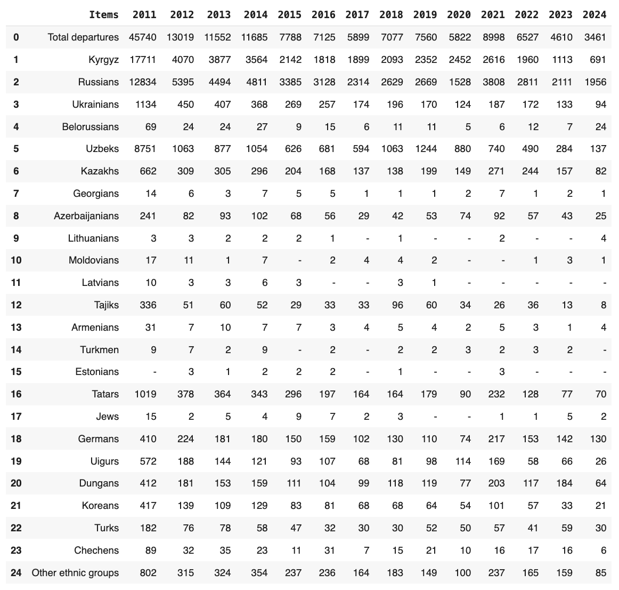

Source:<https://stat.gov.kg/ru/opendata/category/323/>

Arrivals/Departues by countries of arrival and departure has the same problems especially in the Baltic region:

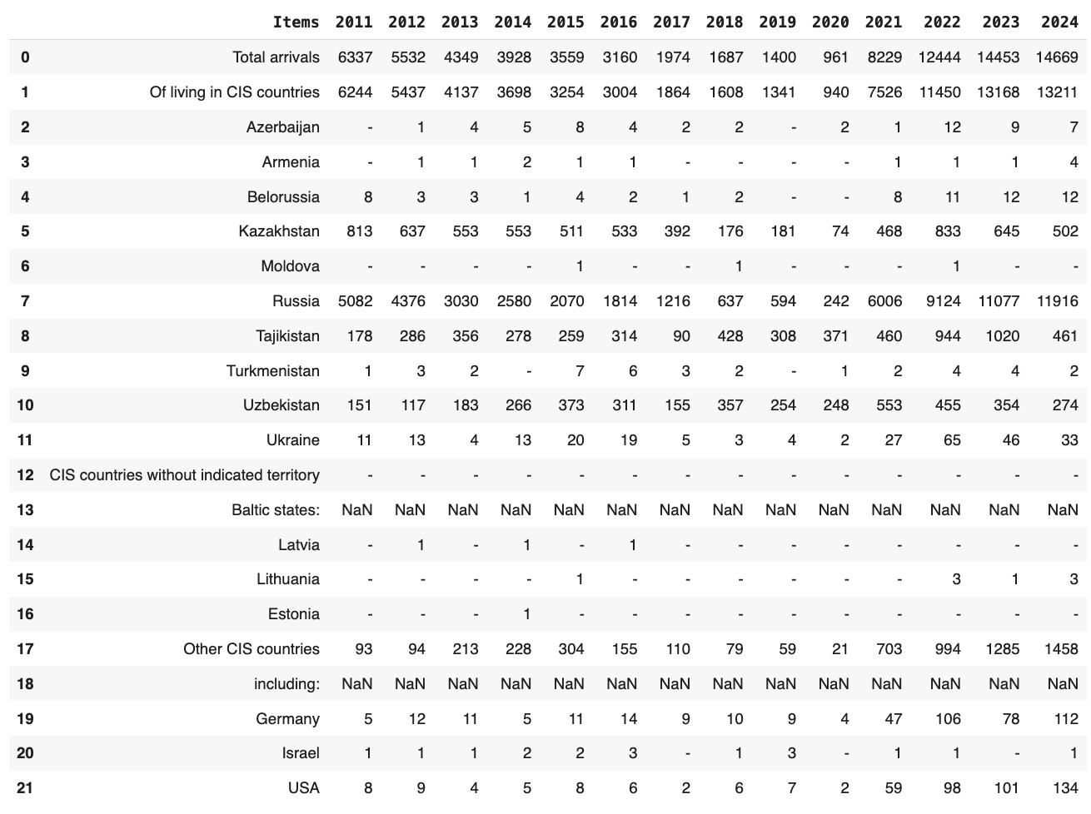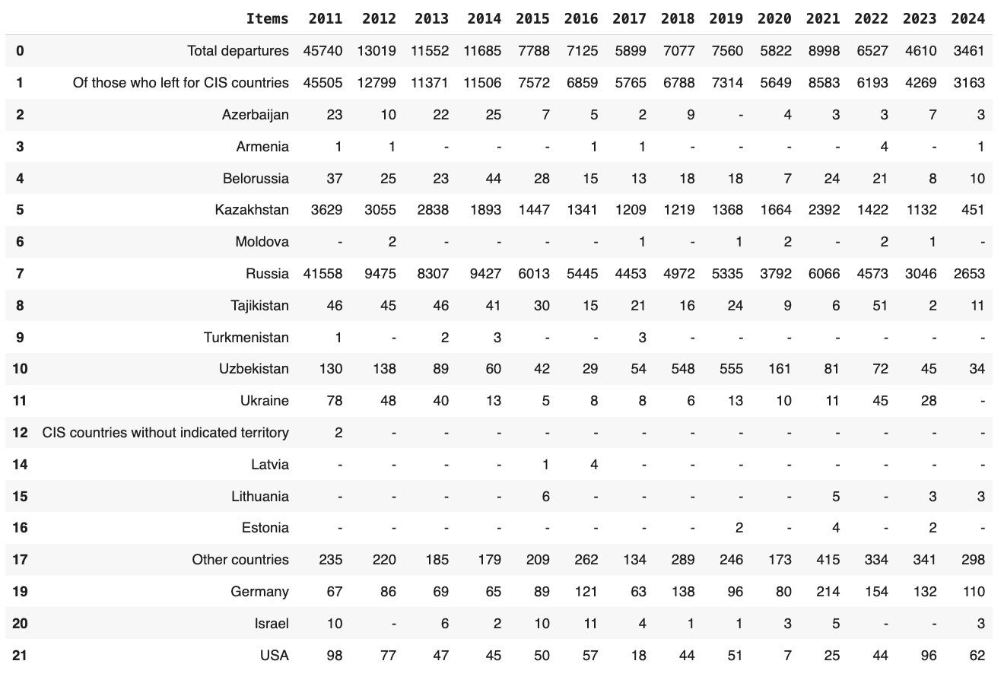

Source: [https://stat.gov.kg/ru/opendata/category/324/](https://stat.gov.kg/ru/opendata/category/323/)

Data for regional migration looks more complete, however still needs more detailed information(age,sex,destination,etc.)

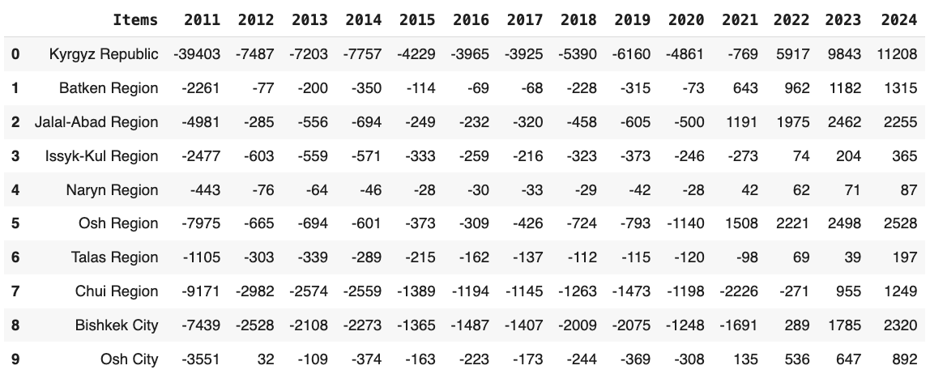

# 2.3 Important General Details on DataSets

An initial review of the data reveals that a significant portion is missing, the available information is largely superficial, and substantial preprocessing is required to ensure the data is suitable for meaningful analysis. Except of Regional migration, the Data is incomplete and requires additional preprocessing.

## 2.3.1. Ethnic Structure of Departures

The analysis of overall departures from Kyrgyzstan by ethnicity between 2011 and 2024 is of interest in a number of ways. In 2011, total departures were 45,740, and among them ethnic Kyrgyz (17,711), Russians (12,834), and Uzbeks (8,751) made up the majority of the emigrants. Year by year, the total number of departures went down significantly, to 3,461 in 2024. The most significant drop can be observed among ethnic Kyrgyz, whose departures fell over 90% over the period, from 17,711 in 2011 to a mere 691 in 2024. The same trend can be observed for Russians, although their outflow was fairly stable in recent years, with 1,956 departing in 2024. Exits of other ethnic minorities, such as Ukrainians, Germans, Tatars, and Dungans, were fairly modest throughout the whole period but always followed the overall declining trend. This tendency points to an overall shift in emigration flows, with decreasing numbers of nationals leaving the country in total among all ethnic groups, possibly due to changing economic, social, or geopolitical factors within the country and elsewhere.

## 2.3.2 Emigrations by Destination Country (CIS vs. Non-CIS)

Emigrations by destination country further substantiate the CIS as the primary migration route. In 2011, 45,505 individuals—over 99% of all emigrants—traveled to CIS nations. Although total departures declined in subsequent years, the CIS remained the preferred destination. Russia was the top receiving country, accepting over 90% of CIS-bound migrants annually. However, departures to Russia plummeted, from 41,558 in 2011 to 2,653 in 2024. Other major CIS destinations include Kazakhstan and Uzbekistan, though they accepted migrants in much lower numbers. On the other hand, CIS migration to nations such as Germany and the United States remained subdued throughout the period. Nevertheless, these numbers have registered a slight rise since 2021, suggesting a gradual diversification of the destination area for migration from the CIS region. This may be due to shifting preferences of migrants due to political instability in the CIS countries, economic opportunities elsewhere, or shifting policies governing cross-border migration.

## 2.3.3. Arrivals by Country of Origin

In contrast to falling emigration rates, arrival statistics indicate a remarkable increase, particularly in recent times. Between the years 2011 and 2020, arrivals were modestly low at between 961 and 6,337 per annum. The pattern changed radically beginning in 2021, as arrivals increased to 8,229 and 14,669 by 2024. The majority of the people entering Kyrgyzstan were from CIS countries, particularly Russia, which received the most inflows—increasing from 594 entries in 2019 to 11,916 in 2024. Major inflows were also noted from Tajikistan and Uzbekistan. This sudden increase in arrivals can be attributed to regional instability, economic crises in the host states, or Kyrgyz nationals coming back home. The increase in migration from Russia in particular can be attributed to recent shifts in geopolitics that affect mobility, e.g., shifts in labor needs or political crackdowns. The data show that Kyrgyzstan is becoming a destination nation for migrants, opposite past trends of net emigration.

## 2.3.4. Net Migration by Region

The overall pattern of net migration across Kyrgyzstan between 2011 and 2024 indicates a revolutionary shift. During the time span from 2011 to 2020, every region experienced negative net migration, which meant that migrants were leaving in greater numbers than entering. Maximum net losses were in Chui Region, followed by Bishkek City, and Osh Region. But from the year 2021 onwards, everything began to change as most regions turned positive in terms of net migration. Overall, the Kyrgyz Republic recorded a net growth of 11,208 individuals by 2024. Bishkek City reported a net positive migration of 2,320, while Osh Region and Jalal-Abad Region recorded increases of 2,528 and 2,255 respectively. This shift shows that some of the regions may now be attracting either returning migrants or new settlers from other nations or other regions in the nation. Reasons for this trend could be internal economic development, improved infrastructure, and shifts in regional labor demand. These regional trends support the overall national trend for Kyrgyzstan to become less a nation of net emigration to becoming a nation of net population inflow.

---------------------------------------------------------------------------

# 3. Data Analysis

## 3.1 Data Preprocessing

Throughout the course of this chapter, we will provide an exhaustive overview of the preprocessing done on one of the datasets as an example. This is for the purpose of making sure that we remain clear and concise and display the entire spectrum of data preparation techniques utilized throughout the project. It must be added that the same preprocessing steps, that is, cleaning, transformation, and formatting, were applied systematically across all other datasets discussed in the analysis to ensure consistency and comparability of results.

If GitHub is more accesible and convenient for you, please follow the link:

<https://github.com/Stalkussia/Data-Analysis-Project.git>

1. Print DataSet fully, to understand what we deal with.

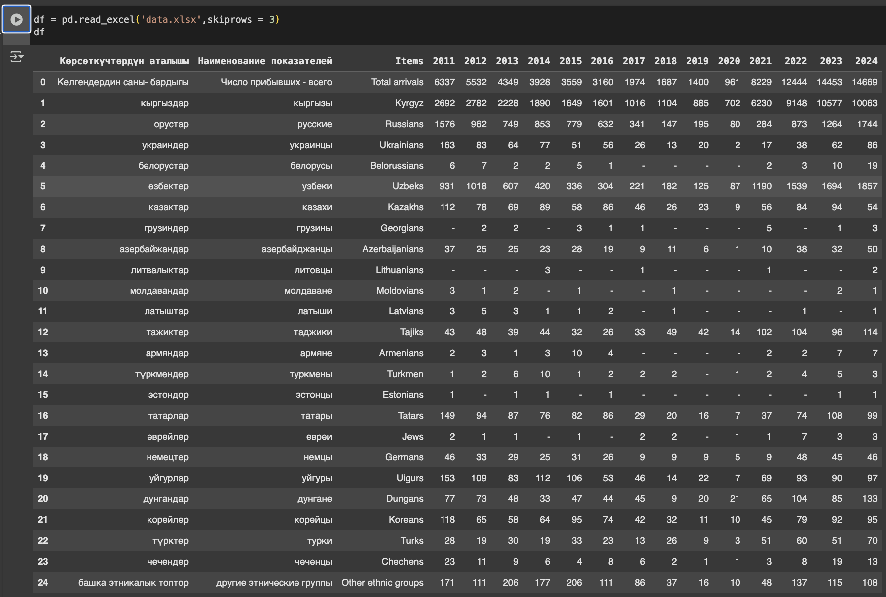

1. Then we check the dataset for duplicated rows, null or Nan values. Delete first two columns in russian and kyrgyz languages for accessability.

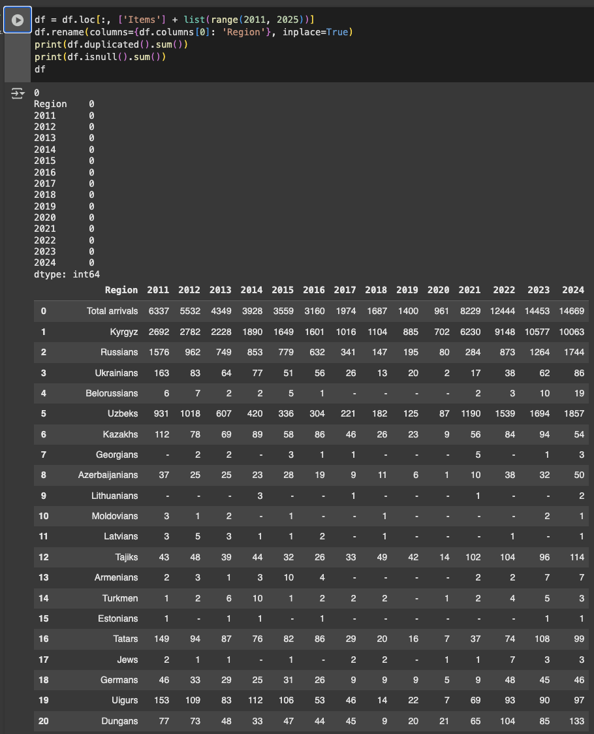

1. Moving on we deal with non-int values ‘-’ by replacing them with 0. And like so, we get clean data, ready to be analyzed ad used.

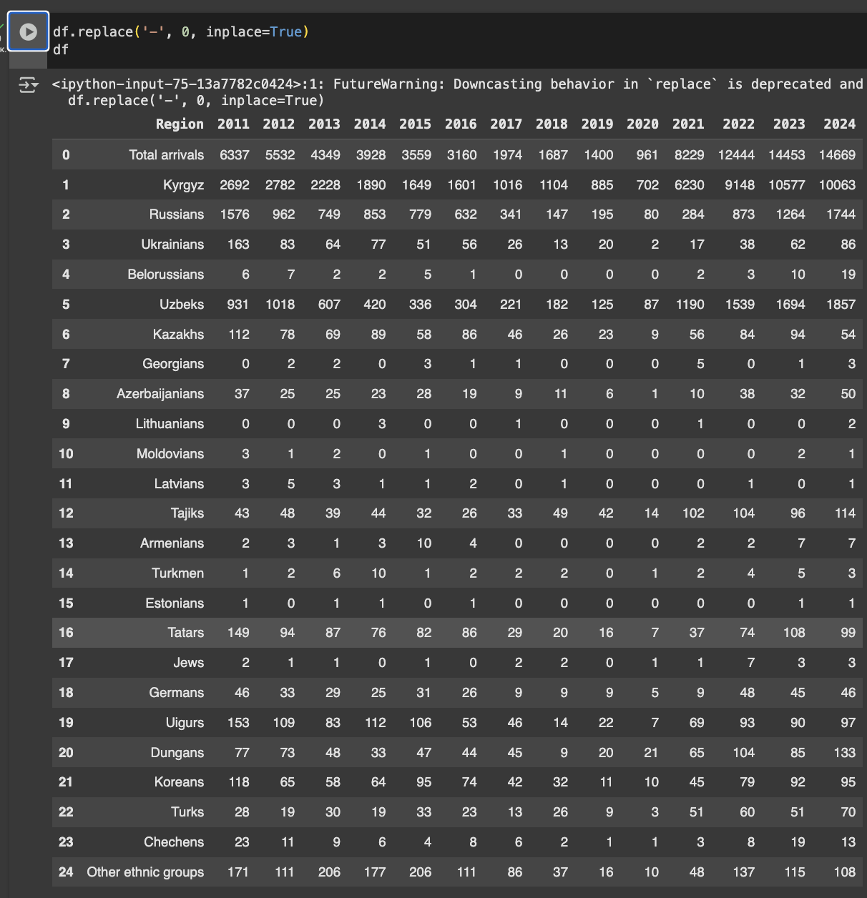

## 3.2 EDA

## Line plot::

**Total Arrivals**: There is a significant decline in migration at some point in 2020, likely due to the COVID-19 pandemic, which shut down international travel. Migration seems to recover and increase after the decline, with a huge surge in 2021, most likely a post-pandemic bounce.

**Kyrgyz**: The pattern of Kyrgyz migrants follows the same as total arrivals, suggesting that they constitute a major proportion of the migration stream. The pattern is relatively consistent, with a decline in 2020 (consistent with the global migration trend in the pandemic).

**Russians**: The number of Russian migrants initially decreases but seems to stabilize and even rise slightly after 2020. This could indicate shifting migration patterns or increased mobility due to socio-economic or political factors in Russia.

**Uzbeks**: Uzbeks maintain a steady and high presence in Kyrgyzstan's migration data, falling in 2020 and recovering slowly after the pandemic. Uzbeks are likely to be a major ethnic group migrating to Kyrgyzstan due to regional dynamics.

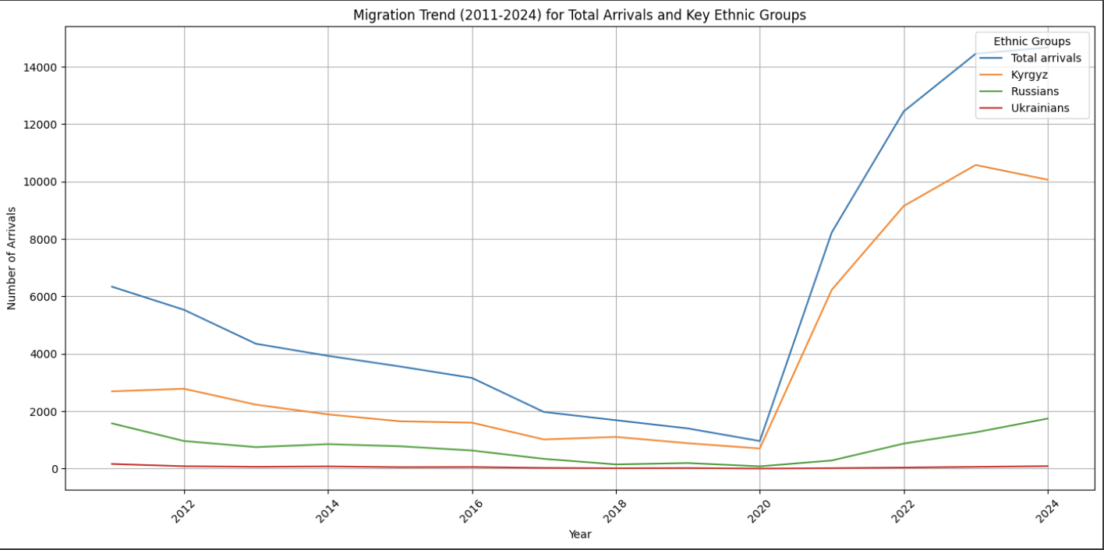

## Heat Map:

**Yearly Trends**: We observe the fluctuations in the migrants for each of the ethnic groups year by year. Some years have sharp rise (e.g., 2021 and 2022) and some have dips (e.g., 2020, the pandemic year). The heatmap also correctly indicates the migration decline during the pandemic year 2020, when all the ethnic groups experienced sizable decreases.

**Concentration of Migration**: The ethnic groups like Kyrgyz, Russians, and Uzbeks dominate the dataset, while groups like Armenians, Lithuanians, and Moldovians have smaller numbers. This also validates the hypothesis that migration is extremely reliant on regional and historical ties.

**Ethnic Group Comparisons**: Some ethnic groups, such as Kyrgyz and Russians, have stable migration patterns for the last decades, while others are varying. For example, there is a rather stable presence of Uzbeks, while Ukrainians and Belorussians have varying swings.

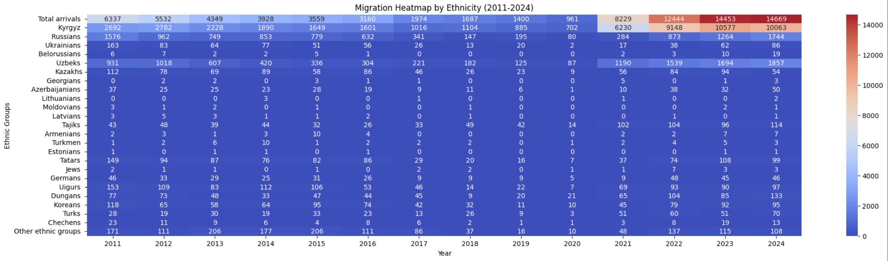

## Pie Chart:

**Kyrgyz Dominance**: The pie chart indicates that the majority of migrants in 2024 are Kyrgyz. This is also evident in the line plot, where Kyrgyz migration was a massive share of overall arrivals over the years.

**Other ethnic groups**: Russians, Uzbeks, and Tajiks are some of the other groups that make a significant percentage, although much lower than the Kyrgyz migrants. The minority groups, Armenians and Lithuanians, make up an insignificant portion of the whole migration stream.

**Other Ethnic Groups**: The 'Other ethnic groups' category, which includes the smaller ethnic groups, represents a small portion of the migration stream, but again, it is extremely small in comparison to the larger groups like Kyrgyz and Russians.

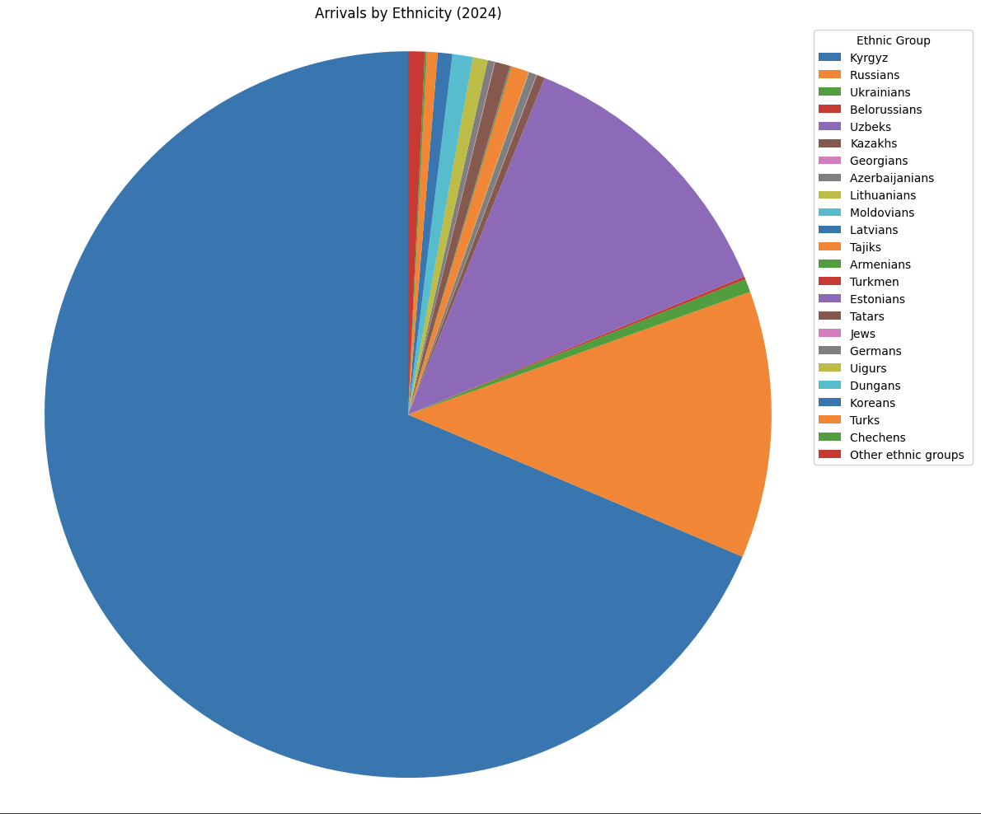

## 3.3 Key Takeaways:

**Effect of Pandemic**: The year 2020 had a very negative effect on migration, as it is reflected by almost all groups having a steep fall in numbers.

**Kyrgyz Dominance of Migration**: Kyrgyz migrants have always comprised a considerable percentage of the total arrivals to Kyrgyzstan. This could be due to inherent demographic trends or policies of countries facilitating migration.

**Regional Dynamics**: Uzbeks' and Russians' migration and other Central Asian ethnic groups signal high regional dynamics of migration. Such migrants are potentially pushed by considerations like work opportunities, socio-political preferences, and similar cultural affinities.

**Multiple Ethnic Groups**: The presence of smaller ethnic groups such as Armenians, Lithuanians, and Moldovians reflects how immigration from Kyrgyzstan is not only local but also includes immigrants who come from other parts of the globe, perhaps due to some economic reasons or political situations.

## 3.4 Why these charts?

These visualizations give a balanced view of the migration data:

**Line Plot** – Shows migration trends over time by major ethnic groups, enabling identification of spikes or drops between years.

**Heatmap** – Highlights migration intensity for all ethnicities by year, enabling easy visual identification of patterns and anomalies.

**Pie Chart** – Shows the ethnic composition of arrivals for a particular year, showing group shares as a percentage of the total.

# Visualizations

We have three ipynb documents representing the several changes in Kyrgyz migration by nation, country, and region over time, here I will explain the file nation.ipynb

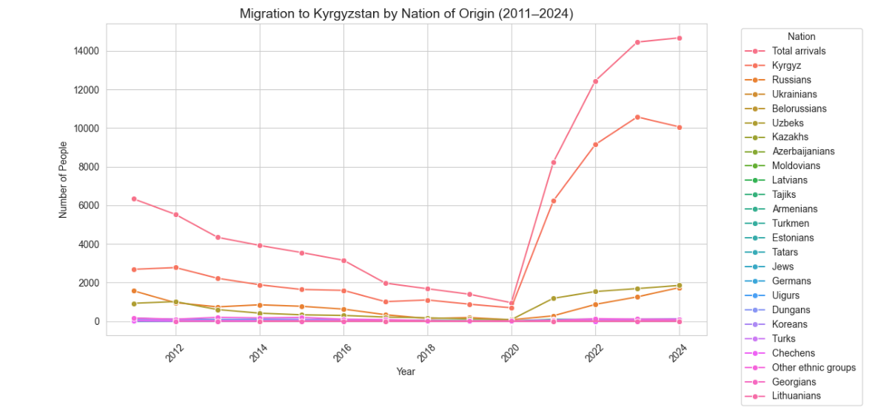

Here we see the lineplot representing the majority of Russians migration to our country, it show also that there are Uzbeks and Kazakhs

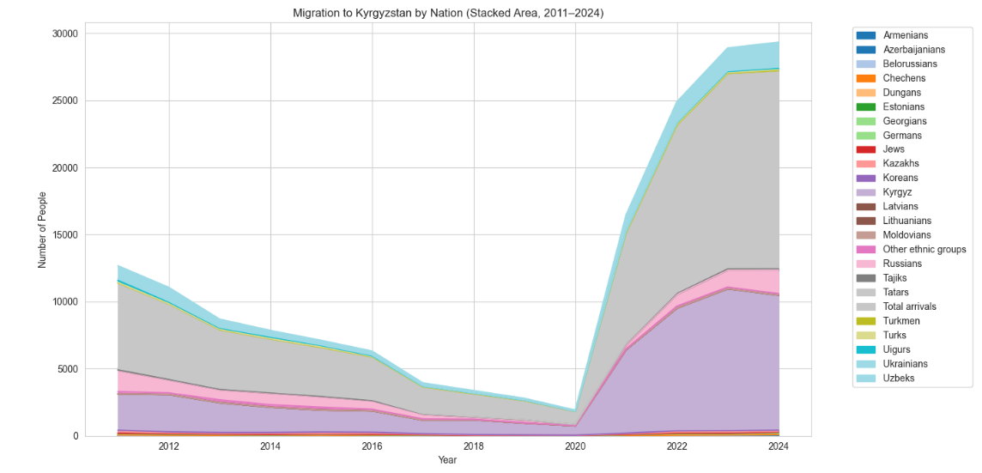

2)Heatmap

Heatmap will show that majority of the migrants are Russian but in other way, with the color difference so we see the contrast between them

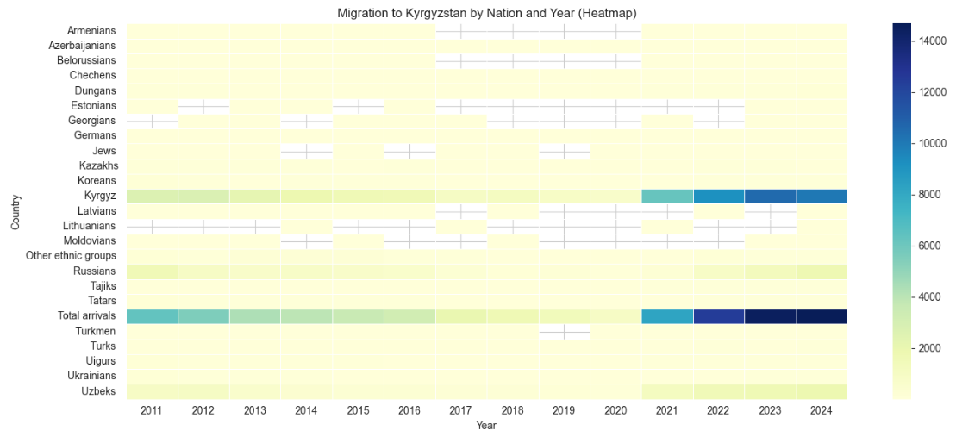

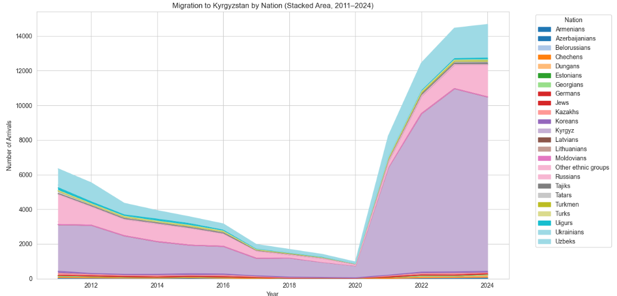

3)Top 5

Here we showed only main data that we are interested in.

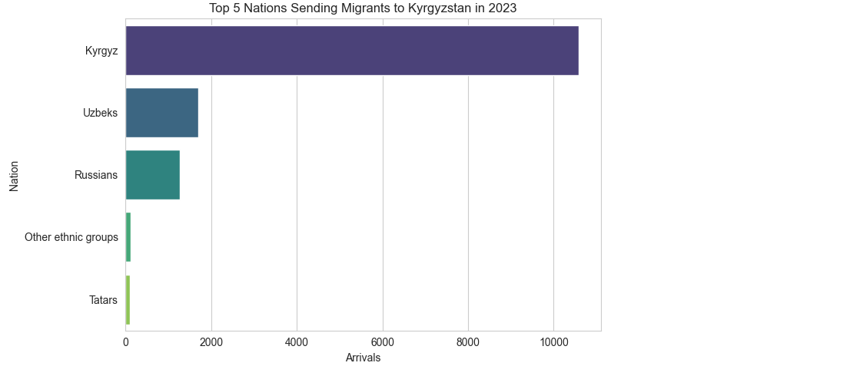

4)Distribution and other graphics showing the majorness of Russian and Uzbeks and Kazakhs by different specific ways  
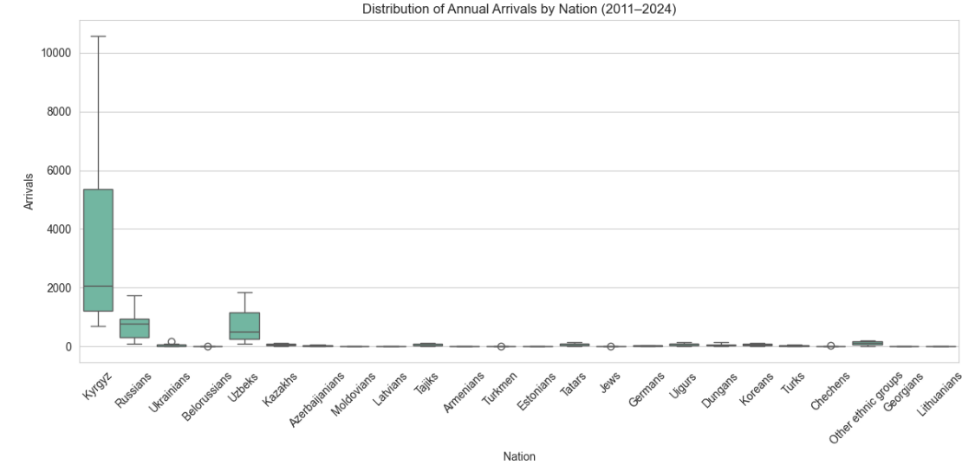

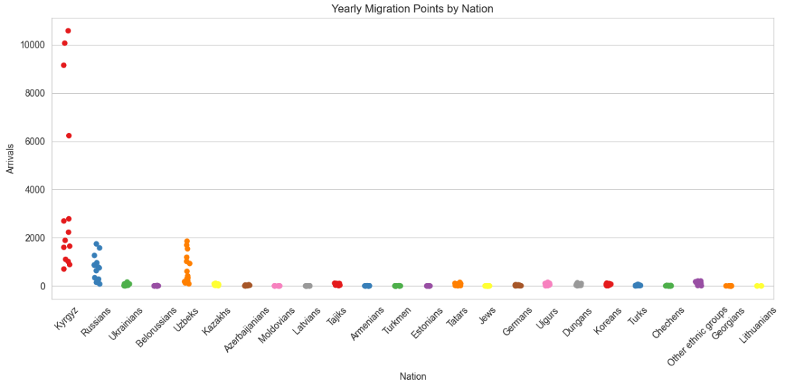

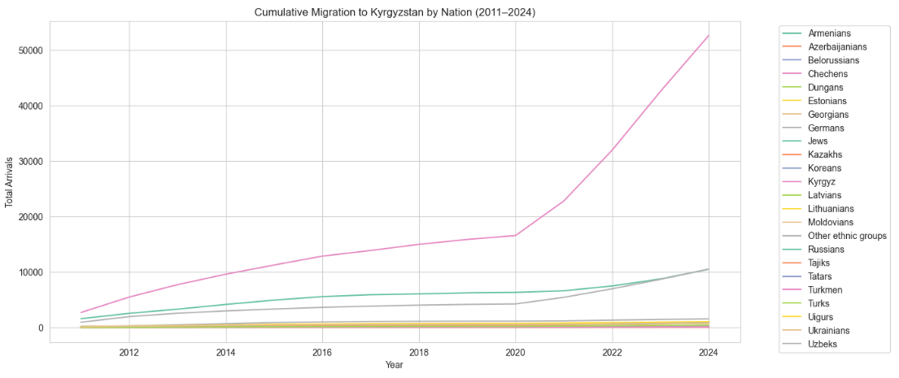

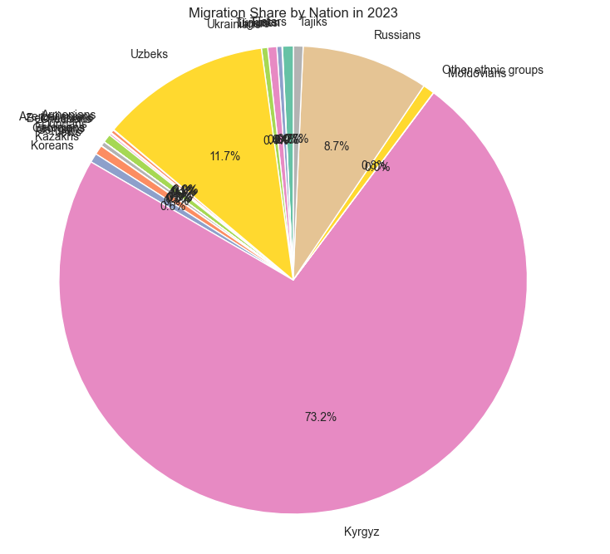

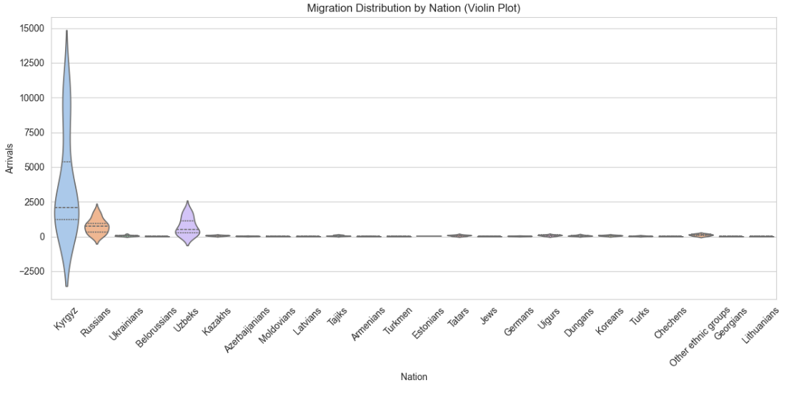

5)Animation – migration race over time

[Migration_race.mp4]



# Conclusion

Between the years 2011-2024, Kyrgyzstan has predominantly experienced net emigration, with departures exceeding arrivals consistently. This was especially true between the years 2011-2020, where departures typically exceeded arrivals by a ratio of 3:1 and above. But things dramatically changed from 2021 onwards when arrivals increased exponentially. This increasing tendency of emigration continued through to 2024, finally ending the gap between departures and arrivals. This can be accounted for by changes in migration policy, regional politics, or improved economic conditions within Kyrgyzstan, and suggests a potential return to more equilibrated or even positive net emigration in the near future.

We initially collected information on migration in and out of Kyrgyzstan between the years 2011 and 2024 from sources. This was in the form of comprehensive datasets containing total numbers of arrivals and departures, categorized according to ethnicity, departure/arrival country, and regions. We then processed and tabulated the raw data to ensure uniformity and data readiness for analysis.

In our exploratory research, we discovered that from 2011 to 2020, Kyrgyzstan experienced consistent net emigration, with emigration greatly outpacing immigration. There was a major reduction in migration activity observed in the year 2020, which is directly attributed to the COVID-19 pandemic. Global lockdowns, travel restrictions, and economic uncertainty led to substantially reduced emigration as well as immigration for the year.

With regards to ethnic composition, ethnic Kyrgyz comprise the majority of both emigrants and returnees. Notably, the level of Kyrgyz in-migration jumped firmly after 2021, potentially due to citizen repatriation from overseas or rising repatriation flows. Ethnic Russians, previously a major element of emigrants, have seen a steady decline in both out-migration and in-migration, corresponding to population adjustments or reduced migration incentives. These communities, such as Uzbeks, Dungans, and Tajiks, reflect fairly stable patterns in migration and contribute smaller but consistent amounts to inflows and outflows. Uzbeks, for instance, saw the number of arrivals rise after 2020, indicating possible patterns in labor migration or family reunions.

The external and regional trends within the data point to Russia as the primary destination country for Kyrgyz migrants, aligning with traditional labor migration currents. Return migration to Russia and other countries in the CIS has occurred in greater numbers over recent years. This may be the result of economic instability in foreign countries, politics such as the conflict between Russia and Ukraine, or enhanced living standards at home.

Statistical analysis lends evidence to these conclusions. Annual departures and arrivals are extremely positively correlated and demonstrate that they both react to broader systemic factors such as regional politics or economic conditions. Linear regression also supports a significant trend relationship between the two variables. Additionally, a paired t-test likely identifies a statistically significant disparity between arrivals and departures, especially for the years prior, to add to the belief that Kyrgyzstan was disproportionately a country of emigration over much of the period under study.

Overall, the migration environment of Kyrgyzstan from 2011 until 2024 is that of a ten-year net emigration, succeeded by a sharp and recent increase in entries, predominantly of Kyrgyz nationals. Such a new pattern may mark the beginning of a new migration epoch for the nation, one determining the path to stabilization, potential return migration, and population integration.

## 5.1 What have we done so far?

We began by collecting data from sources that were available regarding migration out and into Kyrgyzstan between 2011 and 2024. We had comprehensive datasets in terms of total arrival and departure, by ethnicity, country of origin/destination, and regions. We cleaned and compiled the raw data after we had amassed it to render it uniform and amenable for analysis.

We then conducted exploratory data analysis (EDA) to observe overall patterns of migration over time. We identified significant trends, such as a long-term trend of net emigration and a dramatic reversal beginning approximately around 2021. We followed up with statistical analysis, including correlation analysis, linear regression, and hypothesis testing, to learn more about the associations between variables like total arrivals and departures.

Finally, the data has been organized for further manipulation or visualization, enabling us to easily generate charts, tables, or deeper analyses in the future. This preliminary work sets the stage for generating a complete report, building a dashboard, or presenting findings in a professional format.

# 6. References

- International Organization for Migration (2024). Migration Data Mapping — Kyrgyzstan.  
- National Statistical Committee of the Kyrgyz Republic (NSC KR)  
- UN DESA, UNHCR migration statistics  
- Additional sources as used

<https://kyrgyzstan.iom.int/sites/g/files/tmzbdl1321/files/documents/2024-04/compilation_report_dec_2023.pdf>

<https://kyrgyzstan.iom.int/sites/g/files/tmzbdl1321/files/documents/2024-07/mtm-data-mapping_eng_final_0.pdf>

<https://stat.gov.kg/ru/opendata/category/323/>

[https://stat.gov.kg/ru/opendata/category/324/](https://stat.gov.kg/ru/opendata/category/323/)

<https://publications.iom.int/books/migration-governance-indicators-second-profile-2022-kyrgyz-republic-russian>

<https://kyrgyzstan.iom.int/sites/g/files/tmzbdl1321/files/documents/2024-06/compilation-report_apr_sep23_kyr_final-ru.pdf>